BYLAWS of CAPE COD VILLAGE CLUB, INC.

A Not-For-Profit Corporation organized under the laws of the State of New York, adopted by the membership at the meeting of the Corporation on May 25, 2019

ARTICLE I - CORPORATION

Section 1.1 Name of Corporation
This corporation shall be known as the CAPE COD VILLAGE CLUB, INC.

Section 1.2 Definitions
For the purposes of this document, the following terms and their corresponding definitions shall apply:
- Cape Cod Village Club Inc. and CCVC shall describe the Association which is described within these Bylaws.
  - CCVC shall mean the property shown on the attached county tax map with lot numbers and a list of lots.
- "Owner" shall mean a person or entity that holds title to real property in Cape Cod Village Club, Inc. An owner can be an individual or individuals, a partnership, a trust, a Limited Liability Company, a Corporation, or any combination of these.
- “Member” shall mean:
  - All individual(s) listed on the deed of the real property.
  - All partners in a partnership which owns in CCVC
  - All trustees of a trust which owns real property in CCVC.
  - All Corporate Officers of a Corporation which owns real property in CCVC.
  - All the members of a Limited Liability Company which owns real property in CCVC.
- "Membership" shall mean the total of all 33 properties in CCVC.
  - Each property is considered to have one membership. A current list of CCVC memberships is maintained by the secretary as needed.
  - Each membership is entitled to one vote. Its holder shall be entitled to vote at corporate meetings.
- “A member or membership in good standing” is a member or membership that meets all of the appropriate conditions of these Bylaws and has complied with all the deadlines for all dues and special assessments as established by the Board of Directors and approved by the membership.

Section 1.3 Purpose of the Corporation
The purpose of the corporation shall be:
- To provide a not for-profit recreational residential community, having community access and certain rights as follows:
  - To use the CCVC beach areas.
  - To use recreational areas and playgrounds in CCVC
  - To use the CCVC workshop
  - To use the boat docks and swim platforms owned by CCVC
  - To use CCVC roads
- To purchase, hold, and maintain in good condition all CCVC property.
- To maintain the water supply system in proper operating condition for the use of members for a period commencing weather permitting, Mid-May and ending Mid-October, or later at the discretion of the Board of Directors. The Corporation must have available a person qualified to operate the water system as required by law.
- To establish, impose and enforce regulations with respect to the use of all corporate facilities.
- To cooperate with the Lake George Park Commission, the New York State Department of Environmental Conservation and the State of New York and other state and local agencies for the preservation of the waters of Lake George and the lands and waterways adjoining the same.
- To operate Cape Cod Village Club, Inc., in accordance with the laws of the State of New York and the Town of Hague, especially with respect to the water system and sanitary facilities.
- To promote cooperation among owners in Cape Cod Village Club, Inc.

ARTICLE II - Membership

Section 2.1 Membership Registration
Membership shall be limited to those persons identified in Section 1.2. sub-section (3) who meet the following conditions:
- A new owner must register with the CCVC secretary by filling out and signing the following forms supplied by the CCVC secretary and paying the following fees at time of transfer of real property.
- Completing and signing a CCVC Bylaw Acknowledgment Form which states the new owner has received the current Bylaws and will abide by them.
- Completing and signing a CCVC Owner/Membership Registration Form which lists all property owners and their contact information.
- Pay a one-time Membership fee in the amount of 50% of current annual dues.

If either of the forms or the fee is not submitted within 30 days of change of ownership, the membership would lose its status as a membership in good standing.

The new owners are responsible to pay all current dues, special assessments and delinquent dues or fees.
- All current owners must register with the CCVC Secretary by filling out and signing the following form supplied by the CCVC Secretary and paying the following fees at time of transfer of real property.
- Completing and signing a CCVC Bylaw Acknowledgment Form which states the owner has received the current Bylaws and will abide by them. A new CCVC Bylaw Acknowledgement Form must be filed whenever the Bylaws are revised.
- Completing and signing a CCVC Owner/Membership Registration Form which lists all property owners and their contact information. A new CCVC Owner/Membership Registration Form must be filed whenever the deed to the property is changed.

If either one of the forms is not submitted within 30 days of change of ownership or revisions of Bylaws, the membership would lose its status as a membership in good standing.

The owners are responsible to pay all current dues, special assessments and delinquent dues or fees.

Section 2.2 Transfer of Real Property
- In the event of the sale of real property, the seller shall be automatically terminated as a member. The purchaser of such residence or property becomes a member on the day of closing as long as terms set-forth in Article II Section 2.1 are met.
- Seniority, with two exceptions, will be determined by the date that a deed transfers ownership of a property in CCVC.
- One exception will be an event in which an existing owner exchanges for a different property within CCVC, his/her seniority will not change.
- When ownership is transferred or modified and the previous owner remains an owner on the new deed, the seniority will not change.
- Upon the death of a member, any remaining owners on the deed will retain their seniority.
- The CCVC secretary will compile a list of owner’s seniority and provide copies annually.

ARTICLE III - Government

Section 3.1 Board of Directors
The general management of the affairs, funds and property of the Corporation shall be vested in the Board of Directors, who shall be elected pursuant to Article V of these Bylaws.

The total number of Directors shall not be less than three (3) and not more than ten (10). At least three of these Directors shall be the four officers. The remaining board members shall be those duly elected. The goal is to have a minimum of seven (7) Directors.

The selection of Directors is defined by the certificate of incorporation.

Section 3.2 Officers
The officers of the Corporation shall consist of a minimum of President, Secretary, a Treasurer and an optional Vice President.

ARTICLE IV - Meetings/Parliamentary Authority

Section 4.1 Meeting Schedule
There shall be two (2) meetings each calendar year. The first meeting of the year shall be on the Saturday preceding Memorial Day. The second meeting of the year shall be the annual meeting and shall be on the Saturday preceding Labor Day. The dates of the above-mentioned meetings may be postponed by the Board of Directors on notice to the membership and the postponed date shall not be more than fourteen (14) days from the date fixed for such meeting by the Bylaws.

Section 4.2 Special Meetings
Special meetings of members may be called by the President at any time or upon request of four (4) members of the Board of Directors or upon request of nine (9) voting members in good standing, made to such officer in writing. Such notice shall state the reasons for such meeting, the business to be transacted and by whom called. At such special meeting, unless all of the voting members present in person or by proxy consent thereto, there shall only be considered such business as is specified in the notice of meeting and no other business.

Section 4.3 Quorum Definition
At all meetings of the Corporation, either regular or special, a majority of all voting members in good standing, present in person or by-proxy, shall constitute a quorum.

Section 4.4 Adjournment Conditions
If a quorum is not present at any meeting the presiding officer may adjourn the meeting to a specific day and hour, but such adjourned date shall not be more than fourteen (14) days from the date fixed for such meeting by the Bylaws. If the meeting is to be a regular meeting and not more than seven (7) days from the date fixed for such meeting by the notice thereof, the meeting shall be a special meeting.

Section 4.5 Meeting Notices
All notices of regular and special meetings, together with a proxy shall be mailed or emailed by the Secretary to all member’s addresses as they appear on the membership roll book at least fifteen (15) days but not more than thirty (30) days before the date of such meeting. If more than one person is an owner of a real property in said Cape Cod Village Club, Inc., only one notice need be sent to the owners of such real property.

Members shall specify their preference for mailing or emailing Cape Cod Village Club correspondence. In the event no preference is specified, e-mail will be used. The secretary will maintain a mailing preference list.

Section 4.6 Question Procedure
All questions which may arise at a meeting, the manner of deciding which is not otherwise prescribed by the Bylaws, shall be decided by a majority of the voting members present in person or by proxy.

Section 4.7 Officer Ballot Procedure
Election of officers and directors shall be by ballot if there's more than one candidate and there shall not appear on such ballot any writing, mark or figure which might identify the person who cast the ballot.

Section 4.8 Voting Procedure
At any regular or special meeting, if a majority of the persons present in person or by proxy so approve, any question may be voted upon in the manner provided for the election of officers and directors as specified in Section 4.7 of this Article IV.

Section 4.9 Proxy
A member of the Corporation entitled to vote at a meeting as provided in subdivision (4) of Section 1.2 of Article I, may vote by proxy. A proxy shall be in writing and revocable at the pleasure of the member executing it. Unless the duration of the proxy is specified, it shall be invalid after sixty (60) days from the date of its execution.

Section 4.10 Order of Business
The order of business shall be as follows at all the meetings of the Corporation and Board of Directors:
- Calling of the Roll.
- Proof of Notice of Meeting or Waiver of Notice.
- Reading of minutes.
- Receiving of Communications.
- Election of Officers.
- Reports of Officers.
- Reports of Committees.
- Unfinished Business.
- New Business.

Any question as to priority of business shall be decided by the Chair without debate.

The order of business may be altered or suspended at any meeting by a majority vote of the members present who are entitled to vote as specified in subdivision (4) of Section 1.2 of Article I.

Section 4.11 Board of Directors Meetings
Meetings of the Board of Directors shall be held at such time and place as determined by a majority of the members of the Board. Notice of regular or special meetings of the Board shall be given by the President or Secretary to each member thereof, at least three (3) days prior to the date fixed for such meeting. Such notice may be given verbally, or in writing.

Section 4.12 Board of Directors Quorum
A majority of all Board of Director members, present in person, or via electronic conference (e.g. phone, video, Facetime), shall constitute a quorum.

Section 4.13 Board of Directors Voting Procedure
At a meeting of the Board of Directors, each Director shall be entitled to one (1) vote. Such vote must be cast in person or via electronic conference methods. Votes may not be cast by proxy.

If more than one member from a single membership sits on the Board at the same time, they will only be allowed one vote

Section 4.14 Meeting Governance / Robert’s Rules
The rules contained in the current edition of "Robert’s Rules of Order Newly Revised." shall govern the Cape Cod Village Club, Inc., in all cases to which they are applicable and in which they are not inconsistent with these Bylaws and any special rules of order the Corporation may adopt.

ARTICLE V - Election of Officers and Directors

Section 5.1 Term
The Officers and Directors of the Corporation shall be elected by the membership at the annual meeting for a two (2) year term, effective upon adjournment of the annual meeting. Each candidate for office must be a member in good standing of the Corporation and shall be nominated from the floor by recommendation of the Nominating Committee or by a member in good standing. Each voting member in good standing shall be entitled to one (1) vote for each officer position and one (1) vote for each director. The candidates receiving a majority of the votes cast shall be declared elected. The total number of directors shall not be less than three (3) and not more than ten (10). At least three of these Directors shall be the four officers. The goal is to have a minimum of seven (7) Directors.

ARTICLE VI - Vacancies in Office

Section 6.1 Board of Directors Vacancy
If a vacancy occurs among the officers or in the Board of Directors, the vacancy shall be filled for the unexpired term by the Board of Directors from the membership roll.

ARTICLE VII - Duties and Power of the Board Of Directors

Section 7.1 Overall Duties
The Board of Directors shall have general charge and management of the affairs, funds and property of the Corporation, and it shall carry out the purposes of the Corporation according to the Certificate of Incorporation and Bylaws. Board members are required to act in good faith and in the best interest of all members, to determine whether the conduct of any member violates the rules and regulations of the Corporation and to fix the penalty for such misconduct or any violation of the Bylaws or Rules and Regulations as defined in Section 7.3 set forth below.

Section 7.2 Specific Duties
In addition to any other duties imposed upon the Board of Directors by this Article or any Article of the Bylaws, the Board of Directors shall have the duty and responsibility of:
- Making rules and regulations for the conduct of members, their families and guests and for the use of corporate property and facilities and equipment and defining and limiting the rights and privileges of members, their families and guests, not inconsistent, however, with anything contained in the Bylaws. Such rules shall be approved by a two-thirds (2/3rds) of all voting members present in person or by proxy of the Corporation at a regular or special meeting thereof, before they shall become effective.
- Making and levying assessments against owners of residences or real property in Cape Cod Village for the purpose of paying taxes on corporate property and expenses for the management and operation of the Corporation and the maintenance and repair of its property.
- The Board of Directors shall prepare and submit at each annual meeting, a budget which shall be approved by a majority vote of the members entitled to vote as provided in subdivision (4) of Section 1.2 of Article I hereof. Such budget shall constitute the normal operating budget for taxes, repairs, maintenance and administration expenses for the ensuing year.
- Maintaining and preserving the official records of the Corporation in a safe and protected location.
- Any capital improvement or repair in excess of FIVE THOUSAND ($5,000.00) DOLLARS shall be a separate item in the budget and except in an emergency must be approved with the proposed method of financing by a majority of the voting members of the Corporation at a regular meeting or at a special meeting called for the purpose of considering such capital improvement and the method of financing it.
- Arranging for Officers and Directors insurance and adequate insurance against the damage or destruction of corporate property by fire or other casualty and for the protection of the corporate property and the members of the Corporation against any liability arising out of the use of corporate property or facilities.
- Contracting for personnel to perform services required for the proper maintenance and operation of corporate property and the administration of the Corporation and its facilities and affairs.
- The Board of Directors will appoint a Dock master and/or dock committee, who will have the duties of assigning members, guests and renters boat slips, oversee dock installation and removal, coordinate dock repairs.

Section 7.3 Bylaw Violations
In the event of a violation to the Bylaws the following process will be used for enforcement.
- Enforcement: If a member is in violation of, or does not conform to the Bylaws and Rules and Regulations of the Corporation, notice of the violation shall be submitted to the Board of Directors by any member. If the Board of Directors has reason to believe there may be a violation, written notice of same setting forth in reasonable detail the nature of such violation shall be forwarded to the member and delivered personally or by certified mail with return receipt. The member will within ten (10) days of receipt of said notice either resolve or initiate a solution to the alleged violation or request a hearing before the Board of Directors.
- Hearing: A hearing can be held in person or through telecommunications, whichever is most appropriate at the time and under the circumstances. If the Board, following the hearing, determines that no violation has occurred the member shall be so notified in writing and the matter will be discontinued. If however the Board determines that a violation has occurred it shall provide the member with notice of its finding by delivering same personally or by certified mail with return receipt. Said notice shall specify in detail the finding of the Board, the reason for its determination, the steps it will require the member to take to cure the violation and a reasonable time frame for the member to cure said violation.
- Curing of Violation: If the violation continues after the time allowed for curing same has elapsed, the Corporation, through its agents, may choose to suspend the offending member’s voting rights and membership privileges, exercise the Right of Abatement, as defined in Section (2) below, and/or seek appropriate civil remedies.
- Suspension of Rights. If the violation continues after the time allowed for curing the same has elapsed, the member’s voting rights and membership privileges shall be immediately automatically suspended.
- Right of Abatement. The Right of Abatement means the right of the Corporation, through its agents, to take the actions specified in the notice to the member to abate, extinguish, remove, or repair such violation or take any other steps permitted by law to ensure that violations are corrected with the cost of such action, including reasonable attorneys’ fees, together with interest thereon, to be a binding personal obligation of such member.
- Civil Remedies. In the event the matter or the violation is pursued civilly through the courts and the member is found to have violated the Bylaws, or Rules and Regulations of the Corporation, the Corporation shall be entitled to recover against said member all of the costs of disbursements including attorney’s fees incurred in the litigation of this matter.

ARTICLE VIII - Duties of Officers

Section 8.1 President
The President shall be the chief executive officer of the Corporation and shall preside at all meetings of the Corporation and of the Board of Directors and shall appoint such Committees as the President or the Corporation shall consider expedient or necessary. Committee members shall serve for a period of two (2) years. In addition to the above mentioned duties and any other duties delegated to the President by the Bylaws, the President shall have the following duties:
- shall present at each annual meeting a report concerning the affairs of the Corporation; shall ensure that all reports as required by law are properly filed, maintained and retained, and shall be one of the officers in addition to the Treasurer who may sign checks on behalf of the Corporation.
- shall be a member, ex officio, of all Committees, except the Nominating Committee.

Section 8.2 Absence of President
In the absence or disability of the President, the Vice President shall perform such duties and may exercise all of the rights, powers and privileges conferred upon the President by the Certificate of Incorporation or the Bylaws. In the absence of both the President and Vice President, the Treasurer shall preside and assume the duties of the President.

Section 8.3 Secretary
The Secretary shall keep the minutes of all meetings of the Corporation and of the Board of Directors and shall give notice of all meetings of the Corporation and of the Board of Directors in accordance with Article IV of the Bylaws. The Secretary shall be the official custodian of all records and of the seal of the Corporation. In addition to the above duties and any other duties delegated to the Secretary by the Certificate of Incorporation or the Bylaws, the Secretary shall have the following duties:
- present to the membership at each membership meeting and at each meeting of the Board of Directors, any and all communications addressed to the Corporation or any member of the Board of Directors.
- attend to all correspondence of the Corporation and perform all duties incident to the office of Secretary.

Section 8.4 Treasurer
The Treasurer shall:
- have the care and custody of all monies and securities of the Corporation.
- cause to be deposited in a financial institution designated by the Board of Directors all monies received on behalf of the Corporation.
- sign checks drawn on the corporate accounts.
- render to the Board of Directors and membership an accounting and report of the year's operation at the end of each fiscal year. The fiscal year is January 1 to December 31.
- perform all other duties incident to the office of Treasurer.

Section 8.5 Signature Authority
The President, Vice President or Treasurer shall, on being so directed by the Board of Directors, sign on behalf of the Corporation, all contracts or other instruments in writing.

Section 8.6 Monetary Compensation
No officer or Director shall by reason of such office be entitled to receive any salary or compensation from the Corporation, but nothing herein contained shall be construed to prevent an officer or Director from receiving from the Corporation compensation for services performed in a capacity other than as an officer or Director.

ARTICLE IX - Fees, Dues and Assessments

Section 9.1 Fees, Dues and Assessments
The Board of Directors may assess the owners of real property in Cape Cod Village Club, Inc., for the purpose specified in Section 7.2 of Article VII. The owners of real property shall be liable for a proportionate share of such assessment, and if more than one person owns real property, such owners shall be jointly and severally liable for a proportionate share of such assessment. The assessment shall be due and payable to Cape Cod Village Club, Inc. and sent to the Treasurer on such date as directed in the Notice of Assessment as sent to each owner. Assessments paid fifteen (15) days late will be assessed a ten (10%) percent penalty. After sixty (60) days, the rights and privileges of a member may be suspended or revoked upon notification by the Treasurer of their delinquent status. However, if the Treasurer is notified by a member of personal hardship, no penalty may be assessed; but the member shall be expected to pay at a mutually agreed upon reasonable time. The Board of Directors shall be notified within ten (10) days if a member is in arrears.

ARTICLE X - Architectural Committee

Section 10.1 Architectural Committee Composition
The Architectural Committee shall be composed of at least three (3), but no more than five (5) members, as determined by the chairperson, who shall be appointed for a term of two (2) years. No member of said Committee shall be entitled to any compensation for services rendered as a member of such Committee.

Section 10.2 Architectural Committee Purpose
The Architectural Committee shall review proposed alterations to existing residences and structures and the design of new residences and structures to strive for continuity of the character and integrity of Cape Cod Village and the continued aesthetics and harmony existing therein.

ARTICLE XI - Criteria for Architectural Committee

Section 11.1 Architectural Change Process
- Any member planning construction of a new home, a major remodel, renovation, or an addition or plans to construct or renovate any structure will be required to submit a set of plans to the Architectural Committee for review.
The member must also submit an Architectural Application form along with a refundable deposit equal to $1.00 per total square foot of new construction with a minimum refundable deposit of $500.00 and maximum of $2500.00. Any expenses the club would incur including but not limited to legal fees or site cleanup from construction or damage to club property or other members property are the responsibility of the applicant.
Expenses may be deducted from the deposit. Any remaining balance of the deposit will be refunded within 30 days of completion of the project, whose date is determined by the Board of Directors. Any expenses not covered by the deposit shall be due within 30 days of notice to the applicant that the deposit has been exhausted and additional expenses have or shall be incurred. Examples of structures include but are not limited to sheds, carport, garage, fuel storage tank, fence, generator or any other man made artifact. The member may be required to appear or to have their architect/builder present at an Architectural Committee hearing/meeting and a Board of Directors meeting for the purpose of explaining in detail, using their prepared plans, the following: size and overall dimensions, external structure and design changes, character, balance, scale/proportion and symmetry with the existing community and surrounding area. All plans must comply with the member’s individual deed restrictions (one of the three forms of deed restrictions attached, appendices A – C).
- A member must submit plans, an Architectural Application, and deposit to the Architectural Committee and must get Board of Director’s approval before seeking town approval. This rule does not preclude a member from consulting with the town for application preparation or questions. In the event a member proceeds with the town process before obtaining club approval the club may cease processing the application and may assess a fee of up to $500, which would be deducted from the application deposit.
- The Architectural Committee shall review proposed alterations to existing residences/structures and the design of new residences/structures to ensure continuity of the character and integrity of Cape Cod Village and the continued aesthetics and harmony existing therein. They will review the proposed application to see if they meet the requirements set forth in the Bylaws.
  - The Architectural Committee shall respond to the member who submitted the plans within 7 days, indicating all information required per the Bylaws has been received or letting the member know what additional information is required. If additional information is required, the Architectural Committee will have an additional 15 days to respond to the member once the additional information is received and deemed complete.
  - Once the Architectural Committee has determined an application is complete, as described in the Bylaws, the Architectural Committee shall notify the general membership within 15 days, providing details in order to solicit all members’ input and concerns. The general membership can provide feedback within 30 days from receiving notification from the Architectural Committee.
  - The Architectural Committee will present all information for the plans, including members’ input and concerns, with their recommendation to the Board of Directors within 15 days of completing the solicitation of all member’s input. The Board of Directors will review the plans and members’ concerns, and will clarify any issues with applicant.
  - The Board of Directors will approve or reject the plans within 15 days of the receipt of the information from the Architectural Committee. Written notification of the decision will be supplied by the Board of Directors to the applicant.
  - The approval will remain valid for a period of two years from date of approval. If construction does not begin within two years of approval, the board may review the plans to see if they adhere to any bylaw changes since approval.
  - The applicant must meet with at least two board members to discuss the construction process and how it relates to the bylaws before construction can begin.
  - Exterior construction must be completed within two years of start of construction.
  - If the Architectural Committee and Board of Directors deny the building request of a member, said member has the right to appeal the decision to the general membership at the next scheduled meeting or special meeting. A final decision rendered by a two thirds vote of the membership present and proxy shall rule.
- Any building or any part thereof, constructed, altered or improved shall conform to the Bylaws as well as those rules and regulations as set forth by the Town of Hague and Warren County building codes and/or ordinances.

Section 11.2 Architectural Application Process
- Applicant submits plot plans with a survey showing lot with all structures visible. Examples of structures include but are not limited to tanks, generators, garages, carports, fences and any other man made artifact.
- Applicant must submit architectural drawings showing all exterior views with measurements. The views should include doors, windows, trim, siding and colors.

Section 11.3 Criteria to meet
The architectural criteria to meet, depends on the lot location and associated size. Section 11.3.A describes the criteria for all lots, excluding lots 1, 2, 3 and 4 to the west of NY State Route 9N. Section 11.3.B identifies the criteria for lots 1, 2, 3 and 4 to the west of NY State Route 9N.

Section 11.3.A East of 9N
Criteria for development, excluding lots 1, 2, 3, and 4, west of NY State Route 9N (as described in Map of a proposed subdivision for Robert Ragot, Situate in Town of Hague, County of Warren, State of New York, dated 5 February 2013):
- Maximum height of 22 feet. This measurement is made from 8 inches above the existing grade, or the top of the existing foundation (whichever is higher), to the top of the highest roof peak.
- The footprint (measured using exterior wall dimensions) may not exceed a total of 1400 square feet. The following ARE considered part of the footprint: residence, porches (covered or uncovered), decks (covered or uncovered), covered stoops, bays, bulkhead doors, and all other covered areas (unless specified otherwise). The following ARE NOT considered part of the footprint: sheds, garages, carports, uncovered stoops and ground level patios.
- Only the 1400 square foot footprint may have living space. No living space is allowed in or above garages, sheds or any other outbuilding.
- The design of new or renovated structures must be consistent with the harmony, balance, scale, proportion, consistency, and character of the existing structures in the Club as determined by the Board of Directors.
- Changes to the original footprint must adhere to setbacks as specified by the deed restrictions, even if the original footprint does not adhere to these setbacks.

Section 11.3.B West of 9N
Criteria for development on lots 1, 2, 3, and 4 west of NY State Route 9N (as described in Map of a proposed subdivision for Robert Ragot, Situate in Town of Hague, County of Warren, State of New York, dated 5 February 2013) is shown below. Note: Lot 1 shall also comply with the Ragot agreement, dated 25 March 2013, on file with the Secretary.
- Maximum height of 25 feet. This measurement is made from 8 inches above the existing grade to the top of the highest roof peak.
- The footprint (measured using exterior wall dimensions) may not exceed a total of 1400 square feet. The following ARE NOT considered part of the footprint: porches (covered or uncovered), decks (covered or uncovered), stoops (covered or uncovered), bays, bulkhead doors, sheds, garages, carports, patios (ground level or raised) and all other covered or uncovered areas other than the main living structure.
- Only the 1400 square foot footprint may have living space. No living space is allowed in or above garages, sheds or any other outbuildings.
- The design of new structures must be consistent with the harmony, balance, scale, proportion, consistency, and character of the existing structures in the Club as determined by the Board of Directors. Changes to the original footprint must adhere to setbacks as specified by the deed restrictions, even if the original footprint does not adhere to these setbacks.
- The lot to be developed must be a minimum size of 1.1 acres.
- Any structure to be built must adhere to a front, back and side setbacks defined by either the town or deed restrictions, whichever is more restrictive.

Section 11.4 Existing Structures
Structures in existence on August 1, 1993, that do not conform to the architectural restrictions imposed herein shall be allowed to exist. If, however, said nonconforming structures are removed from the property voluntarily or are destroyed by fire or some other casualty, the replacement structure shall be designed to conform to the architectural standards set forth in these Bylaws.

Section 11.5 Restrictions
- There is to be no major construction which would be disruptive to the peace/tranquility and character of the other homes and property from July 3rd through the day after Labor Day. This restriction may be exempt when the home or property requires immediate work due to fire, weather or other unforeseen events that expose the home or property to further damage. Approval to exempt this restriction requires a majority vote by the Board of Directors. Major construction includes, but is not limited to excavation work, roofing, siding, masonry work, repetitive interior or exterior nailing or sawing, prolonged pressure washing, major tree work. Construction equipment should be removed from the job site during the months of July and August and the site should be cleaned up. Construction equipment includes, but is not limited to, heavy equipment, construction trailers, scaffolding, and storage containers. Supplies and material should not block neighbors view and should be covered. Normal maintenance procedures such as lawn mowing, weed trimming, hedge trimming, minor landscaping, cutting firewood, short term pressure washing, painting, minor non-repetitive nailing and sawing are permitted.
- Work in general on grounds or external home repair, cannot begin before 8:00 A.M. and must end by 8:00 P.M.

Section 11.6 Changes to Architectural Applications
There shall be no changes in the plans once they have been approved unless the member and / or architect/designer/builder appears before the Architectural Committee and the Board of Directors to provide a clearly defined description of change(s). The Board of Director then approves changes. A written notice of change(s) will be prepared by Board of Directors and distributed to general membership.

ARTICLE XII – Rules and Regulations – Land Use

Section 12.1 Rules and Regulations
- Any cosmetic change to Corporate Property, i.e., pier area (whips, lifts) should be brought before the appropriate committee for approval.
- No drinking of alcoholic beverages and beverages and food contained in glass containers on beaches or docks. Grills may be used, but no open fires are allowed in the beach area.
- Children under 10 are not allowed to swim without supervision.
- No running on docks and no diving in shallow areas.
- Animals: Pets are not allowed on CCVC grounds or in cottages. One exception: Domesticated cats which are house bound are permitted in owner-occupied residences. Notwithstanding the above, CCVC abides by Federal, New York State and Town laws in regards to member service animals and emotional support animals. CCVC’s Reasonable Accommodation Policy and Reasonable Accommodation Form related to emotional support animals are included as attachments.
- No crossing private property to North Beach. Use roadway from 9N.
- Seniority is not the only standard for the assignment of dock space. Dock space is assigned by dockmaster and/or Dock Committee based on size of boat, safety and seniority.
- Only watercraft up to 16 feet may be launched at Club launch areas. If the watercraft is launched by a vehicle it must be 4 wheel drive capable. Only members that are listed on the LGPC Launch Agreement may launch trailered boats from the CCVC launch ramp.
- Boats are not to be used as sleeping quarters.
- The workshop is for adult members. Keys are available from the Buildings Ground and Water committee.
- Cars must be parked in designated areas and not on greens. No minibikes, snowmobiles, or camping vehicles to be used on CCVC grounds. All vehicles including golf carts must observe the 10 MPH speed limit.
- No boats larger than 22’ in length.
- Fishing
- Fishing is permitted on docks and at the Point.
- Children under 10 must be accompanied by an adult member.
- Exercise caution to avoid damage to property or other people.
- In the event that a dock or boat is damaged (e.g. hook in canvas, fishing line wrapped around outdrive, whip tangled), or a person is injured, immediately notify the Dock Master or Board Member, and as applicable, boat owner. Note item #15 below.
- Members renting their homes must:
- Provide the Renter with the Renter's Agreement packet.
- Ensure the Renter understands, signs and returns the agreement to the Member.
- Forward a copy of the signed agreement to the Renter Committee prior to renting.
- Supply a copy of these rules to those people renting their homes.
- If their Renter requires a boat slip, the member must remove their boat in order to make room for their renter’s boat as directed by the Dock Master or Board of Directors prior to the rental start date.
- Individual members will be responsible for any damage to CCVC or personal property caused by themselves, their renters or visiting guests.
- Personal Watercraft not allowed to be docked in deep water slip. A deep water slip is a slip that a 16’ or larger boat could utilize.

ARTICLE XIII - Amendment of Bylaws

Section 13.1 Process
The Bylaws and Rules and Regulations may be amended or repealed during a meeting by an affirmative vote of not less than two-thirds (2/3rds) of all voting members present in person or by proxy as provided in subdivision (4) of Section 1.2 of Article I of these Bylaws.

Section 13.2 Notice
Members shall be given fifteen (15) days notice of any and all proposed changes in the Bylaws in accordance with the provisions of Section 4.5 of Article IV hereof.

Section 13.3 Review Frequency
The Bylaws are to be reviewed every four (4) years.

Section 13.4 Severability
Severability; invalidation of any section of these Bylaws or restrictions by judgment or court order shall in no way effect any other provisions which shall remain in full force and effect.

APPENDIX A

Covenants – Glenn Barnes – Liber 399 Page 271
- The premises shall be used solely and exclusively for single family private residence purposes.
- No buildings shall be erected or reconstructed upon said premises unless or until the grading plan of lot, including the grade elevations of the buildings and structures, the plot plan showing the proposed location of said buildings and structures upon said premises and the plans, specifications and details of said buildings and structures have been approved in writing by the Grantor. Upon completion of the construction of a dwelling house on said premises it shall be conclusively presumed, in so far as any bona fide purchaser or mortgagee from the Grantee is concerned, that the location of said dwelling house and all other buildings thereon has been approved by the Grantor, unless there shall have been recorded in the Warren County Clerk’s Office a notice to the effect that such approval has been withheld.
- No fence, hedge or boundary marker more than four (4) feet in height shall be erected, placed or maintained upon the premises, and no fence, wall, hedge or mass planting shall be permitted to extend nearer to any road than the minimum building setback line.
- The premises hereby conveyed shall not be subdivided.
- No trailer, basement, tent, truck or garage shall at any time be used as a residence, temporarily or permanently, nor shall any structure of a temporary nature be used as a residence on said premises.
- No chickens or other fowl or livestock of any kind will be kept or harbored on said premises.
- No motor vehicles shall be parked on the private roads of the Grantor, except at places set apart by the Grantor for the purpose.
- No business or occupation, or any nuisance whatever, or any trading or manufacturing business, trade or occupation shall be erected, carried on, maintained or permitted on the premises at any time nor shall anything be done thereon which may be or become an annoyance or nuisance to the neighborhood.
- No residence, garage, or out buildings, of any type shall be erected on the said land within twenty (20) feet of any of the roads or roadways, referred to herein, or within twenty (20) feet of any side or rear area, except within the area occupied by the present building.
- The Grantees will pay from time to time such equitable proportion, as may be fixed by the Grantor, of the actual cost including property taxes, to the Grantor of maintenance or furnishing of roads, water supply, bathing beach and adjacent area and other facilities which the Grantor covenants to maintained or furnished hereunder, and of the cost of maintenance of the dock adjacent to the bathing beach area over which the Grantees have an easement, as long as such dock is maintained by the Grantor; provided that such charge shall not be a lien on the premises hereby conveyed and that the receipt of the Grantor shall be conclusive evidence of the payment thereof.
- The Grantor reserves the right to release, or modify the above restrictions as to any portion of the property owned by it at Cape Cod Village, except as to the beach and other recreation area described under easement (3.) above.

APPENDIX B

Covenants – Glenn Barnes – Liber 448 Page 41
- The premises shall be used solely and exclusively for single family private residence purposes.
- No buildings shall be erected or reconstructed upon said premises unless or until the grading plan of lot, including the grade elevations of the buildings and structures upon said premises and the plans, specifications and details of said buildings and structures have been approved in writing by the Grantor. Upon completion of the construction of a dwelling house on said premises it shall be conclusively presumed, in so far as any bona fide purchaser or mortgage from the Grantee is concerned, that the location of said dwelling house and all other buildings thereon has been approved by the Grantor, unless there shall have been recorded in the Warren County Clerk’s Office a notice to the effect that such approval has been withheld.
- No fence, hedge or boundary marker more than four (4) feet in height shall be erected, placed or maintained upon the premises.
- The premises hereby conveyed shall not be subdivided.
- No trailer, basement, tent, truck or garage shall at any time be used as a residence, temporarily or permanently, nor shall any structure of a temporary nature be used as a residence on said premises.
- No chickens or other fowl or livestock of any kind will be kept or harbored on said premises.
- No motor vehicles shall be parked on private roads of the Grantor, except at places set apart by the Grantor for the purpose.
- No business or occupation, or any nuisance whatever, or any trading or manufacturing business, trade or occupation shall be erected, carried on, maintained or permitted on the premises at any time nor shall anything be done thereon which may be or become an annoyance or nuisance to the neighborhood.
- No residence, garage, or out buildings, of any type shall be erected on the said land within eight (8) feet of the boundary line of said land.
- The Grantee will pay from time to time such equitable proportion, as may be fixed by the Grantor, of the actual cost including property taxes, to the Grantor of maintenance or furnishing of roads, water supply, bathing beach and adjacent area and other facilities which the Grantor covenants to be maintained or furnished hereunder, and of the cost of maintenance of the dock adjacent to the bathing beach area over which the Grantee has an easement as long as such dock is maintained by the Grantor; provided that such charge shall not be a lien on the premises hereby conveyed and that the receipt of the Grantor shall be conclusive evidence of the payment thereof.
- The Grantor reserves the right to release, or modify the above restrictions as to any portion of the property owned by it at Cape Cod Village.
- In the event that the Grantee shall desire to sell, the Grantor shall have the right to purchase the parcel herein conveyed, together with the buildings and improvements thereon erected by paying to the Grantee an amount equal to that of any bonafide offer. The Grantee shall give notice of his intention to sell in writing, fixing amount of the bonafide offer and the Grantor shall have ten (10) days from the receipt of the said notice to either accept of decline.

APPENDIX C

Covenants – Glenn Barnes – Liber 471 Page 430
- The premises shall be used solely and exclusively for single family private residence purposes.
- No buildings shall be erected or reconstructed upon said premises unless or until the grading plan of lot, including the grade elevations of the building and structure upon said premises and the plans, specifications and details of said buildings and structures have been approved in writing by the Grantor. Upon completion of the construction of a dwelling house on said premises it shall be conclusively presumed, in so far as any bona fide purchaser or mortgage from the Grantees is concerned, that the location of said dwelling house and all other buildings thereon has been approved by the Grantor, unless there shall have been recorded in the Warren County Clerk’s Office a notice to the effect that such approval has been withheld.
- No fence, hedge or boundary marker more than four (4) feet in height shall be erected, placed or maintained upon the premises.
- The premises hereby conveyed shall not be subdivided.
- No trailer, basement, tent, truck or garage shall at any time be used as a residence, temporarily or permanently, nor shall any structure of a temporary nature be used as a residence on said premises.
- No chickens or other fowl or livestock of any kind will be kept or harbored on said premises.
- No motor vehicles shall be parked on the private roads of the Grantor, except at places set apart by the Grantor for the purpose.
- No business or occupation, or any nuisance whatever, or any trading or manufacturing business, trade or occupation shall be erected, carried on, maintained or permitted on the premises at any time nor shall anything be done thereon which may be or become an annoyance or nuisance to the neighborhood.
- No residence, garage, or out buildings, of any type shall be erected on the said land within eight (8) feet of the boundary line of said land.
- The Grantee will pay from time to time such equitable proportion, as may be fixed by the Grantor, of the actual cost including property taxes, to the Grantor of maintenance or furnishing of roads, water supply, bathing beach and adjacent area and other facilities which the Grantor covenants to maintained or furnished hereunder, and of the cost of maintenance of the dock adjacent to the bathing beach area over which the Grantees have an easement as long as such dock is maintained by the Grantor; provided that such charge shall not be a lien on the premises hereby conveyed and that the receipt of the Grantor shall be conclusive evidence of the payment thereof.
- The Grantor reserves the right to release, or modify the above restrictions as to any portion of the property owned by it at Cape Cod Village.
- In the event that the Grantee shall desire to sell, the Grantor shall have the right to purchase the parcel herein conveyed, together with the buildings and improvements thereon erected by paying to the Grantee an amount equal to that of any bona fide offer. The Grantees shall give notice of his intention to sell in writing, fixing amount of the bona fide offer and the Grantor shall have ten (10) days from the receipt of the said notice to either accept of decline.

INDEX

BYLAWS of CAPE COD VILLAGE CLUB, INC. 1
ARTICLE I - CORPORATION 2
Section 1.1 Name of Corporation 2
Section 1.2 Definitions 2
Section 1.3 Purpose of the Corporation 2
ARTICLE II - Membership 3
Section 2.1 Membership Registration 3
Section 2.2 Transfer of Real Property 4
ARTICLE III - Government 4
Section 3.1 Board of Directors 4
Section 3.2 Officers 4
ARTICLE IV - Meetings/Parliamentary Authority 5
Section 4.1 Meeting Schedule 5
Section 4.2 Special Meetings 5
Section 4.3 Quorum Definition 5
Section 4.4 Adjournment Conditions 5
Section 4.5 Meeting Notices 5
Section 4.6 Question Procedure 5
Section 4.7 Officer Ballot Procedure 5
Section 4.8 Voting Procedure 6
Section 4.9 Proxy 6
Section 4.10 Order of Business 6
Section 4.11 Board of Directors Meetings 6
Section 4.12 Board of Directors Quorum 6
Section 4.13 Board of Directors Voting Procedure 6
Section 4.14 Meeting Governance / Robert’s Rules 7
ARTICLE V - Election of Officers and Directors 7
Section 5.1 Term 7
ARTICLE VI - Vacancies in Office 7
Section 6.1 Board of Directors Vacancy 7
ARTICLE VII - Duties and Power of the Board Of Directors 7
Section 7.1 Overall Duties 7
Section 7.2 Specific Duties 7
Section 7.3 Bylaw Violations 8
ARTICLE VIII - Duties of Officers 9
Section 8.1 President 9
Section 8.2 Absence of President 9
Section 8.3 Secretary 10
Section 8.4 Treasurer 10
Section 8.5 Signature Authority 10
Section 8.6 Monetary Compensation 10
ARTICLE IX - Fees, Dues and Assessments 10
Section 9.1 Fees, Dues and Assessments 10
ARTICLE X - Architectural Committee 11
Section 10.1 Architectural Committee Composition 11
Section 10.2 Architectural Committee Purpose 11
ARTICLE XI - Criteria for Architectural Committee 11
Section 11.1 Architectural Change Process 11
Section 11.2 Architectural Application Process 12
Section 11.3 Criteria to meet 12
Section 11.3.A East of 9N 13
Section 11.3.B West of 9N 13
Section 11.4 Existing Structures 13
Section 11.5 Restrictions 14
Section 11.6 Changes to Architectural Applications 14
ARTICLE XII – Rules and Regulations – Land Use 15
Section 12.1 Rules and Regulations 15
ARTICLE XIII - Amendment of Bylaws 16
Section 13.1 Process 16
Section 13.2 Notice 16
Section 13.3 Review Frequency 16
Section 13.4 Severability 16
APPENDIX A 17
Covenants – Glenn Barnes – Liber 399 Page 271 17
APPENDIX B 18
Covenants – Glenn Barnes – Liber 448 Page 41 18
APPENDIX C 19
Covenants – Glenn Barnes – Liber 471 Page 430 19

Attachments

1. County Tax Maps 23
2. List of Lots 24
3. Certificate of Incorporation 25
4. Reasonable Accommodation Policy 28
5. Reasonable Accommodation Form 31
6. Rental Packet 36

1. County Tax Maps
As cited in ARTICLE I - CORPORATION, below find the relevant Warren County Tax Maps:

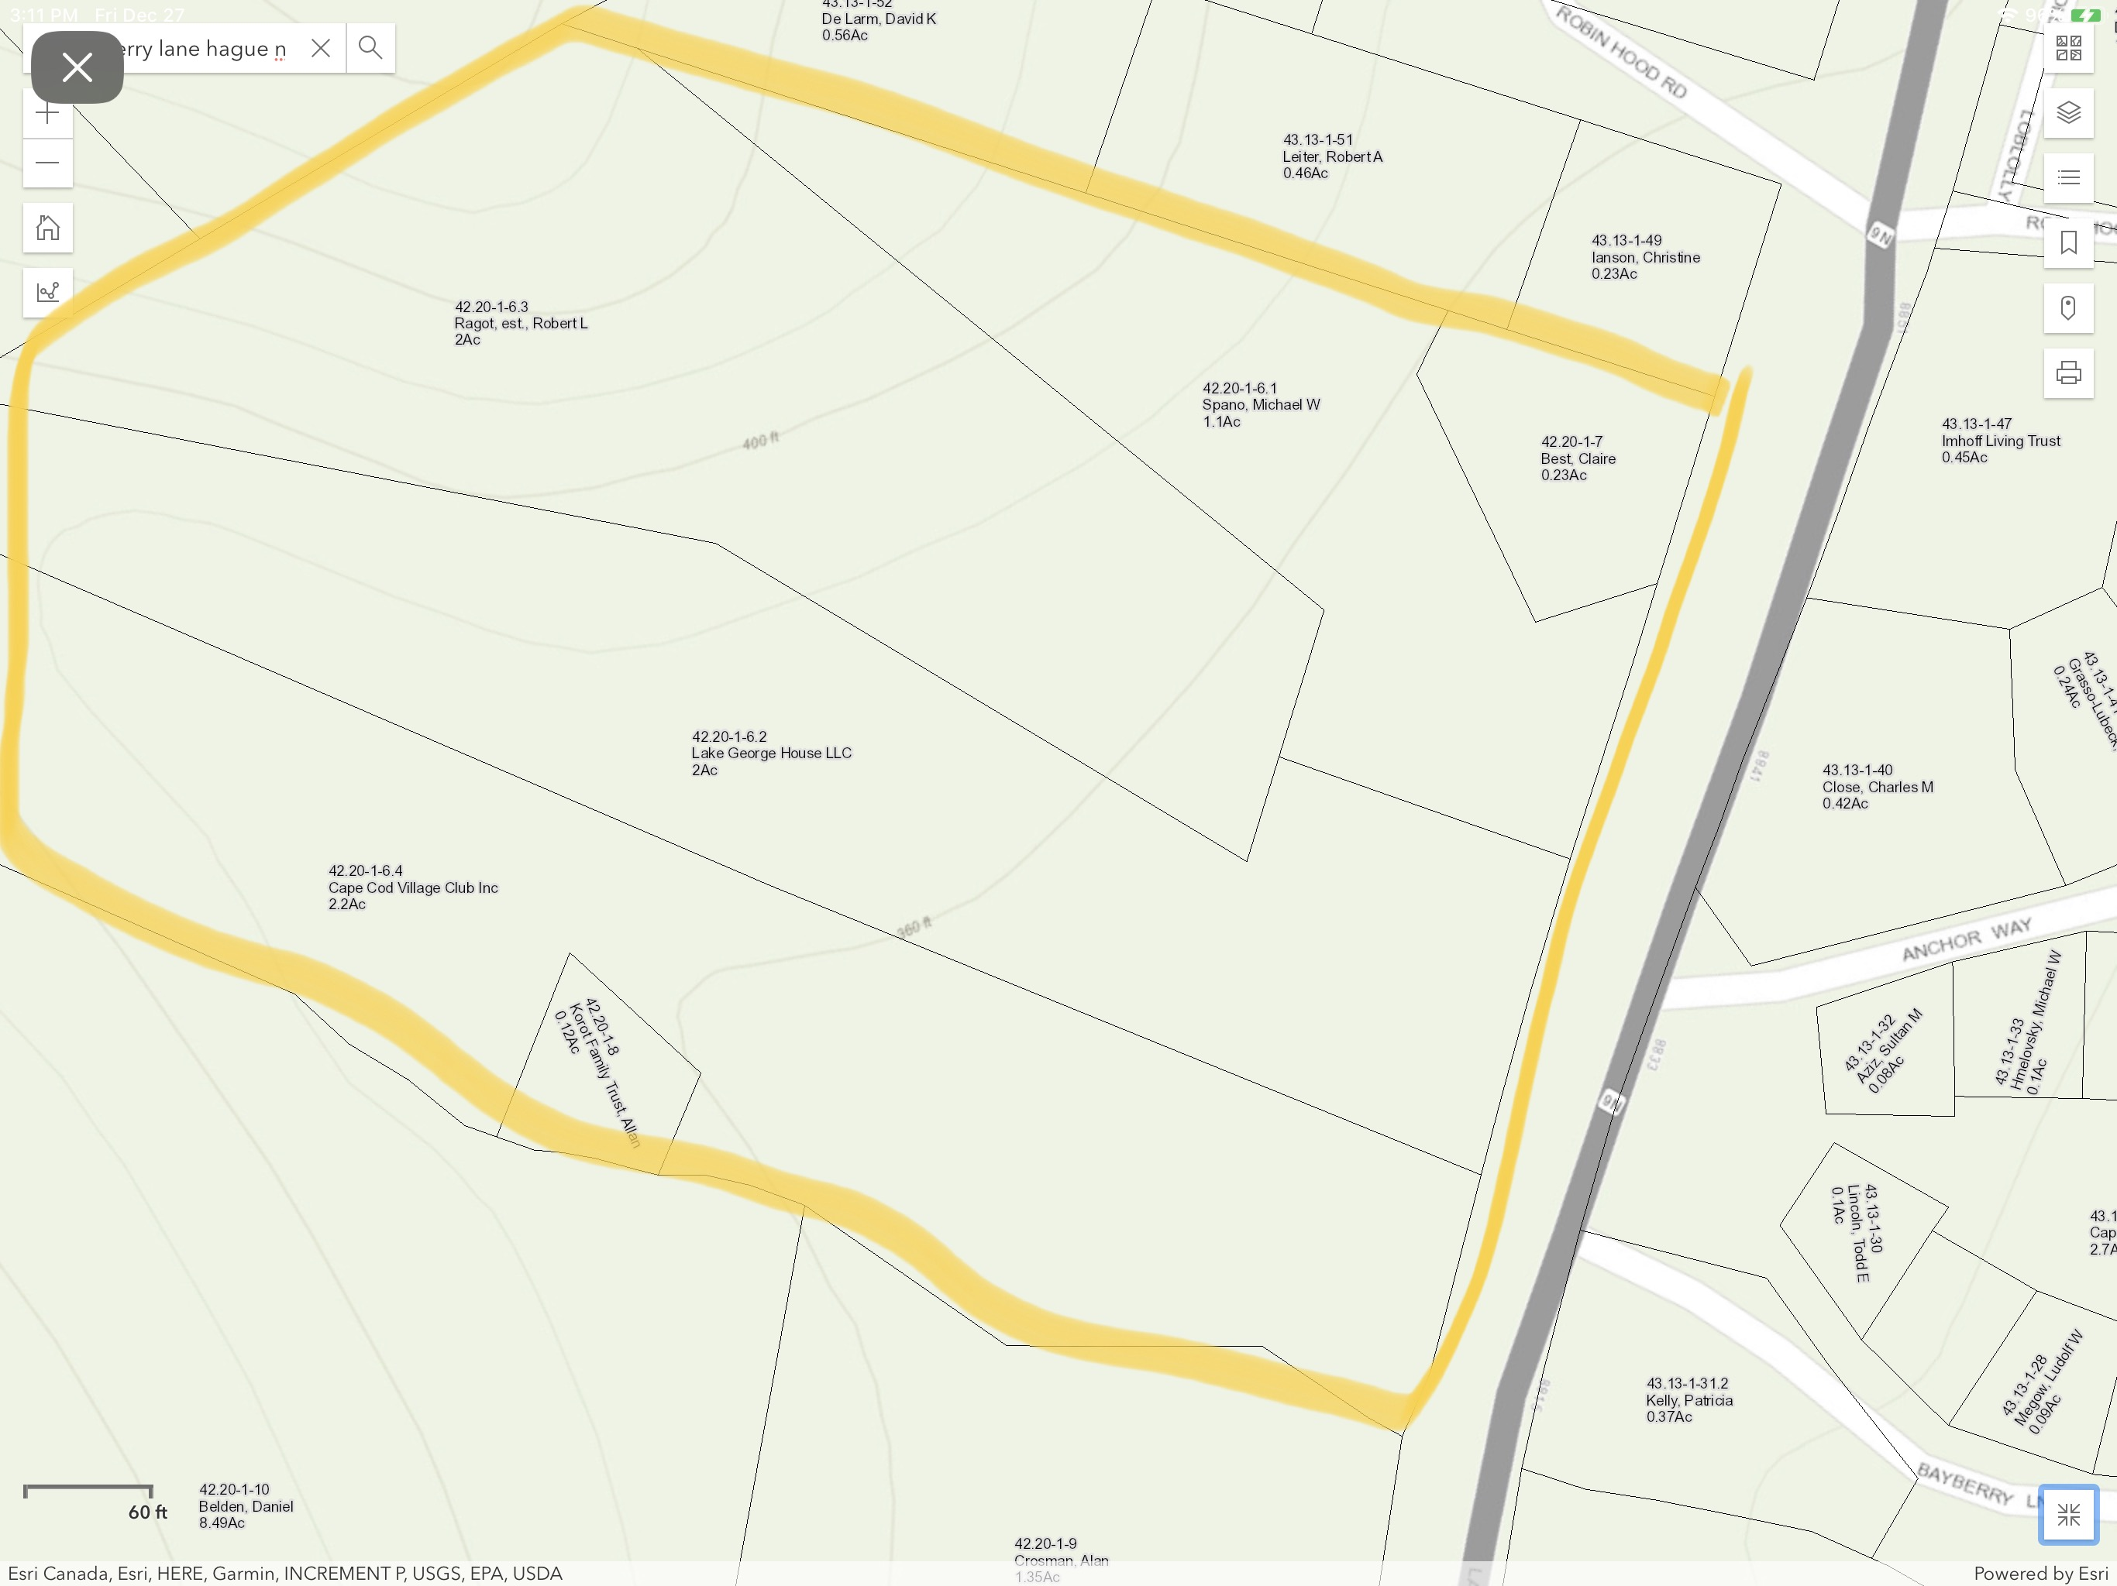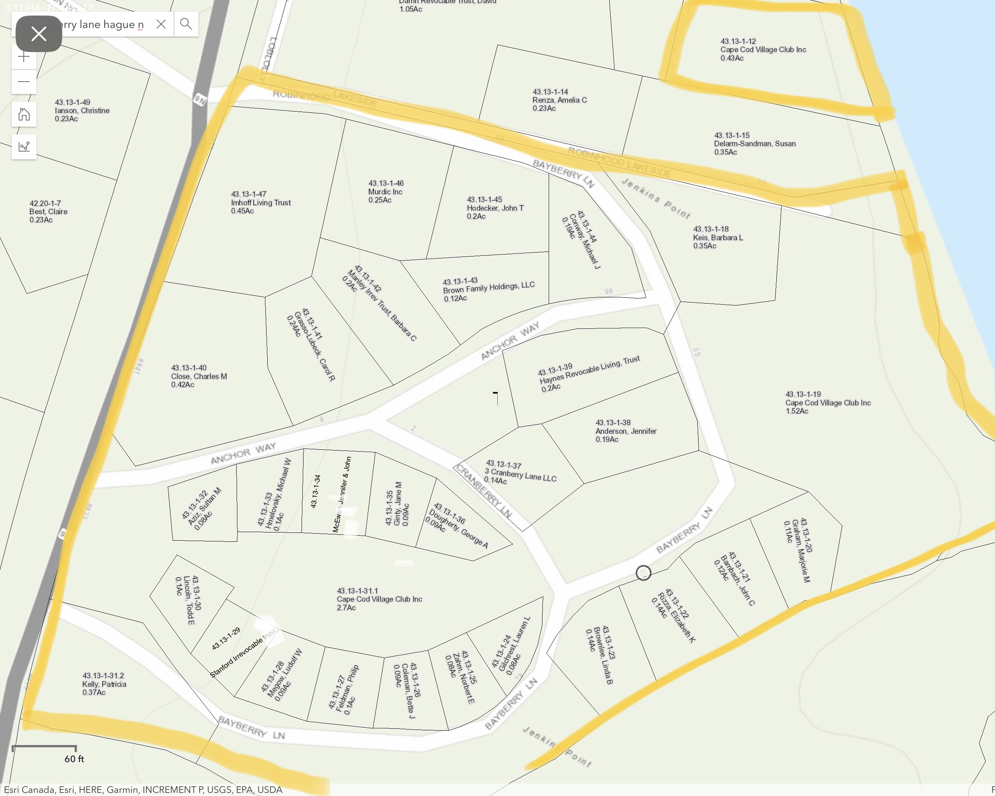

2. List of Lots
As cited in ARTICLE I - CORPORATION, below find the list of CCVC lots, with owners shown as of December 31, 2019:
Tax Map Parcel # | Property Owner(s)
43.13-1-38 | Anderson, Jennifer
42.20-1-6.2 | Lake George House, LLC (Atiyehs)
43.13-1-32 | Aziz, Sultan M; and Aziz, Janet
43.13-1-21 | Bambach, John C and Bambach, Lee Ann
42.20-1-7 | Best, Donald T; Best, Clare; Best, William T and Spano, Karen
43.13-1-37 | 3 Cranberry Lane LLC (Borrello, Dennis)
43.13-1-46 | Murdic Inc. (Brattlof, Muriel)
43.13-1-43 | Brown Family Holdings, LLC
43.13-1-23 | Paul Babson and Barbara Babson Living Trust
43.13-1-40 | Close, Charles Rev. Trust
43.13-1-26 | Coleman, Bette J
43.13-1-44 | Conway, Michael J Trustee and Maureen T Trustee
43.13-1-36 | Dougherty, George A and Dougherty, Patricia G
43.13-1-27 | Feldman, Philip and Feldman, Kathleen
43.13-1-35 | Ginty, Jane M
43.13-1-20 | Graham, Marjorie M; Mann, Carol and O’Donnovan Susan
43.13-1-41 | Grasso-Lubeck, Carol R
43.13-1-24 | Hartl, Walter and Hartl, Helen E
43.13-1-39 | Haynes, Patricia
43.13-1-33 | Hmelovsky, Michael W and Hmelovsky, Nancy W
43.13-1-45 | Hodecker, John T
43.13-1-47 | Imhoff Living Trust (Imhoff, Harry and Imhoff, Carol)
43.13-1-18 | Keis, Barbara L Trust
43.13-1-31.2 | Kelly, Patricia and Dent, Robert
42.20-1-8 | Korot Realty Co, Ltd (Korot, Alan and Korot, Judy)
43.13-1-30 | Lincoln, Todd and Lincoln, Jeffrey
43.13-1-42 | Manley Irrevocable Trust (Manley, Barbara C)
43.13-1-34 | McEwan, Jennifer and McEwan, John
43.13-1-28 | Megow, Ludolf W and Fortier, Joann
42.20-1-6.3 | Ragot, Mary Lynn
43.13-1-22 | Rizza, Elizabeth K
43.13-1-29 | Stanford Irrevocable Trust, George A (Stanford, George A)
43.13-1-25 | Zahm, E Norbert Jr and Zahm, Patricia
42.20-1-6.1 | Spano, Michael W and Karen B.
CCVC Lots
42.20-1-6.4 | Cape Cod Village Club 2.2 acres West of Rt 9N
43.13-1-31.1 | Cape Cod Village Club 2.7 acres Greens / Roads / along brook / lot next to Haynes & Borello (aka “the triangle”)
43.13-1-19 | Cape Cod Village Club 1.52 acres Main Beach and Pump House
43.13-1-12 | Cape Cod Village Club .45 acres North Beach

3. Certificate of Incorporation
As cited in Section 3.1 Board of Directors, below find the Certificate of Incorporation.

Image 1 of 3
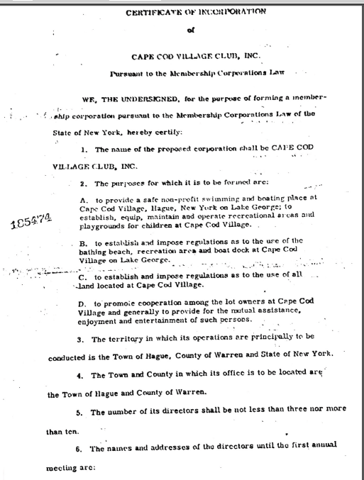

Certificate of Incorporation – Image 2 of 3
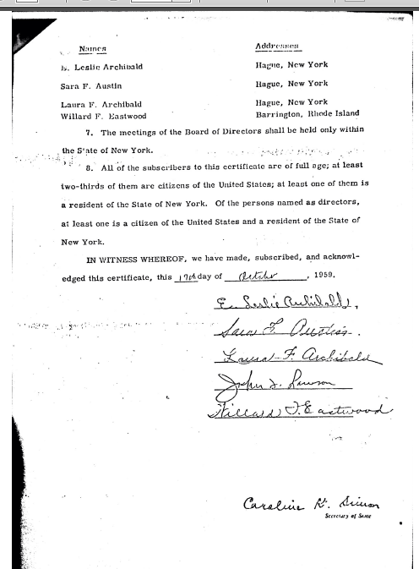
Certificate of Incorporation – Image 3 of 3
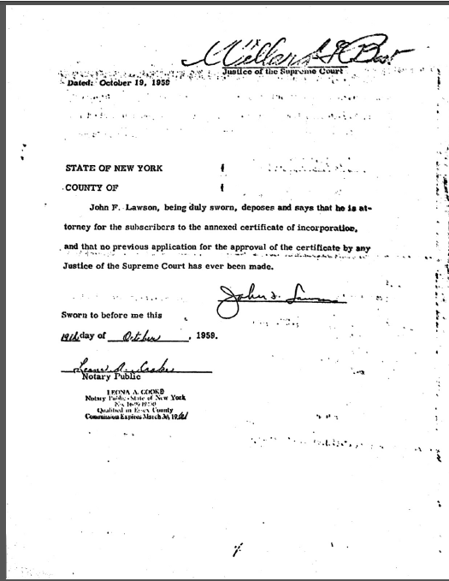

4. Reasonable Accommodation Policy
As cited in Section 12.1 Rules and Regulations, below find the Reasonable Accommodation Policy.

Cape Cod Village Club, Inc.

Reasonable Accommodation Policy

The Federal Fair Housing Act (the “FHA”) and New York state and local fair housing laws require that reasonable accommodations be made for members who have disabilities. Cape Cod Village Club, Inc. (the “Association”) is committed to granting reasonable accommodations when necessary to afford persons with disabilities the equal opportunity to use and enjoy their dwelling at the Association.

Under fair housing laws, a person with a disability is defined as a person who has a physical or mental impairment that substantially limits one or more major life activities, a person who is regarded as having such an impairment, or a person with a record of such an impairment. Reasonable accommodations may include waiving or varying the Association rules or policies to allow members to make reasonable accommodations that are necessary for an individual with a disability to have an equal opportunity to apply for, or use and enjoy, their dwelling at the Association.

If a resident with a disability requests a reasonable accommodation, the Association must determine whether the accommodation is necessary to allow the member an equal opportunity to enjoy their dwelling at the Association. The Association will not ask about the nature or severity of the person’s disability. At times, both the disability and the accommodation are obvious. If this is the case, no further inquiry will be made and the Association will grant the member the reasonable accommodation.

In the case of a member who requests a reasonable accommodation, the Association may require a written statement from a health or social service professional indicating that the applicant has a disability, in addition to the following:

- The Association is entitled to obtain information that is necessary to evaluate if a requested reasonable accommodation may be necessary because of a disability. If a person’s disability is obvious, or otherwise known to the Association, and if the need for the requested accommodation is also readily apparent or known, then the Association may not request any additional information about the requester’s disability or the disability-related need for the accommodation.

If the requester’s disability is known or readily apparent to the provider, but the need for the accommodation is not readily apparent or known, the Association may request only information that is necessary to evaluate the disability-related need for the accommodation.

(b) The Association may not ordinarily inquire as to the nature and severity of an individual’s disability. However, in response to a request for a reasonable accommodation, the Association may request reliable disability-related information that (1) is necessary to verify that the person meets the FHA’s definition of disability (i.e., has a physical or mental impairment that substantially limits one or more major life activities); (2) describes the needed accommodation; and (3) shows the relationship between the person’s disability and the need for the requested accommodation. Depending on the individual’s circumstances, information verifying that the person meets the FHA’s definition of disability.

Once the Association has established that a person meets the FHA’s definition of disability, the provider’s request for documentation should seek only the information that is necessary to evaluate if the reasonable accommodation is needed because of a disability.

In processing request(s) for a reasonable accommodation, the Association will take reasonable measures to protect the confidentiality of any information or documentation disclosed in connection with the request(s). Such measures may include limiting access to such information to persons specifically designated to deal with requests for reasonable accommodations, who will disclose information only to the extent necessary to determine whether to grant the request, and keeping all written requests and accompanying documentation in a secure area to which only those designated persons have access, except as otherwise required by law.

It is the responsibility of a member with a disability to inform the Association as to the need for a reasonable accommodation, and to request a reasonable accommodation and provide any required documentation. A person with a disability must request a reasonable accommodation in writing. To that end, the Association has a “Form to Request a Reasonable Accommodation” (attached to this Policy) which a person with a disability can use to request a reasonable accommodation.

If the applicant requires assistance in completing the attached form, the Association’s Reasonable Accommodation Coordinator or his or her designee will provide assistance or will fill out the form based on an oral request. The Association is using the form to record reasonable accommodation request(s) so that we obtain only the information necessary to make reasonable accommodation decision and do not obtain confidential information that we do not need to make a reasonable accommodation decision.

The term of an approved request will be one year from approval date. Thirty days prior to expiration date, the member must notify the Association’s Reasonable Accommodation Coordinator, in writing, of their desire to renew the request for one additional year. The extension request may require updated documentation.

Once a completed initial or renewal request with all required documentation is received, the Association will provide a response within fourteen (14) days.

Prior to denying any request (initial or renewal), the Association will attempt to engage in an interactive process with the person making the request, in which the parties will discuss possible alternative accommodations that might effectively meet the person’s disability-related needs. The Association recognizes that a person with a disability is generally in the best position to know whether or not a particular accommodation will be effective in meeting his or her needs. If a request is denied, an explanation for the denial will be included in the written notification of denial. If a person with a disability believes that a request has been denied unlawfully or that the response is delayed unreasonably, he or she may file a complaint with:

U.S. Department of Housing and Urban Development
Office of Fair Housing and Equal Opportunity
451 Seventh Street SW
Washington, DC 20410
(800) 669-9777

Manhattan Office:
26 Federal Plaza, Room 3532
New York, New York 10278
(212) 264-5072

Buffalo Office:
Lafayette Court
465 Main Street
Buffalo, New York 14203
(716) 846-5785
Toll Free Number:
(800) 496-4294

All residents, including those with and without disabilities, are required to conduct themselves in a civil and courteous manner at all times, as is reasonable among neighbors living in close proximity to one another. This requires all residents to recognize and respect the federally protected rights of residents with disabilities, and all residents with disabilities to recognize and respect the rights of other residents and their expressed health and safety concerns. All residents are therefore required to cooperate with each other to resolve any issues that may arise regarding such rights.

The Association also requires all reasonable accommodations to be in compliance with any applicable New York state or local laws, including any New York state or local building code requirements.

5. Reasonable Accommodation Form
As cited in Section 12.1 Rules and Regulations, below find the Reasonable Accommodation Form.

Cape Cod Village Club, Inc.

Form to Request a Reasonable Accommodation

The Federal Fair Housing Act (the “FHA”) and New York state and local fair housing laws require that reasonable accommodations be made for Members who have disabilities. Cape Cod Village Club, Inc. (the “Association”) is committed to granting reasonable accommodations when necessary to afford persons with disabilities the equal opportunity to use and enjoy their dwelling at the Association.

A Member who has a disability and believes that there is a need for a reasonable accommodation for the person with the disability to use and enjoy their dwelling at the Association, will complete this form and return it to the Association’s Reasonable Accommodation Coordinator. Please check all items that apply and answer all questions. The Association will respond to this request in writing within fourteen (14) days. All information provided to the Association in connection with this request will be kept confidential, except as otherwise required by law. If you require assistance in completing this form, please contact the Association’s Reasonable Accommodation Coordinator to request help or to make an oral request for a reasonable accommodation.

1. Do you require assistance in filling out this form?

_____ Yes _____ No

If your answer is “Yes,” and you do not have someone who can assist you, please contact the Association’s Reasonable Accommodation Coordinator for assistance in filling out this form.

If your answer is “No,” continue on to Question No. 2.

2. Today’s Date: _____________________

3. The person who has a disability requiring reasonable accommodation is (please check one):

_____ Me. If you answered “Me,” continue to Question No. 4.

_____ A person making a reasonable accommodation request on behalf of, or assisting, the person with a disability. After filling out the following, continue to Question No. 4 and fill out the information regarding the person whom you are requesting a reasonable accommodation:

Name of person filling out form: ______________________________________.

Address: _________________________________________________________.

Telephone Number: ________________________________________________.

Relationship to person needing a reasonable accommodation: _______________.

4. Name of person with a disability for whom a reasonable accommodation is being requested:

________________________________________________________.

Telephone Number: ________________________________________________.

Cape Cod Village Club Street Address: ________________________________________.

5. Are you a person with a disability requesting an accommodation so that you can have an equal opportunity to use and enjoy a dwelling at the Association?

_____ Yes _____ No

6. Indicate the reasonable accommodation(s) you are requesting:

________________________________________________________________________

________________________________________________________________________

________________________________________________________________________

7. Provide the details of the reasonable accommodation(s) you are requesting:

________________________________________________________________________

________________________________________________________________________

________________________________________________________________________

________________________________________________________________________

________________________________________________________________________

8. Is the reasonable accommodation request necessary for you to use and enjoy your dwelling at the Association because of your disability?

_____ Yes _____ No

If the answer is “Yes”:

(a) Provide a written statement from a health or social service professional indicating that you have a disability (i.e., you have a physical or mental impairment that substantially limits one or more major life activities and that the reasonable accommodation is necessary to use and enjoy your dwelling). The statement must include professional credentials such as License Number, Professional Specialty and Contact Information; and

(b) Explain below how the reasonable accommodation(s) would help reduce or alleviate the limitations of your disability:

________________________________________________________________________

________________________________________________________________________

________________________________________________________________________

________________________________________________________________________

________________________________________________________________________

________________________________________________________________________

________________________________________________________________________

________________________________________________________________________

You may provide any additional information or documentation relating to the reasonable accommodation request(s) you describe above and attach it to this application.

If the Reasonable Accommodation involves a dog, by signing below, the applicant agrees to the following conditions regarding the animal:
- It will be confined to the property owned by the applicant (i.e. within the property lines of the Member). It is not allowed on CCVC property including Common Areas such as the Green, Shed, Beach or Association Roads.
- To ensure the rights of other Members to enjoy peaceful possession of their dwelling:
  - When outside the requesting Member’s dwelling, the animal will be leashed/controlled/restrained at all times and accompanied by an adult.
  - Aggressive behavior is not acceptable. CCVC Members, visitors, guests and employees/contractors should not feel threatened.
  - Noise such as barking must be kept to a minimum. To maintain the harmony of the Association, loud or repetitive noise will not be tolerated.
  - Waste must be confined to the Member’s property, promptly removed and properly disposed. Disposing of animal waste in Association sewers, streams or the lake is prohibited.
- The applicant is liable for damage to persons or property within Cape Cod Village associated with the animal. Member must secure and maintain such insurance as will adequately protect Member and the Association from claims for bodily injury, death or property damage that may arise from the dog. Member shall provide the Association with proof of such insurance before the dog is permitted on the property and as requested by the Association from time to time. Member shall name the Association as additional insured and the insurance policy shall contain a provision requiring 30 day written notice to the Association prior to cancellation.
- If the Reasonable Accommodation involves a dog, proof that a Town of Hague Dog License has been obtained. All dogs in the Town of Hague must be registered at the Town Clerk's office. Every dog is assigned a permanent official identification (ID) number and issued a metal ID tag, which must be attached to the dog's collar. Per the Town of Hague website, all dogs three months or older must have proof of a rabies vaccination, signed by a licensed veterinarian. The Town-issued license is valid for one year and renewals will be mailed to the owner. As of January, 2019, the fee is $4.00 if spayed/neutered (as confirmed by a certificate from a licensed veterinarian) or $12.00 if not spayed/neutered.
- Violation of any of the above conditions may result in immediate revocation of the reasonable accommodation and/or withdrawal of the Member’s “good standing” status.

Please provide a description of the animal. A picture is also required and can be sent electronically to the Reasonable Accommodation Coordinator (patgdough@gmail.com).

__________________________________________________________
Name of person making request

____________________________________ ______________________
Signature of person making request Date

TO BE COMPLETED BY THE ASSOCIATION

Form received by: ________________________________ Date ____________

Form confirmed to be complete by: ____________________ Date ____________

Town of Hague Dog License confirmed by: ____________ Date ____________

Professional Credential confirmed by: ________________ Date ____________

Picture received by: _______________________________ Date ____________

Applicant Decision communicated by: ________________ Date ____________

Signature: ____________________________________________

If approved, Expiration Date: _____________________________

6. Rental Packet
As cited in Section 12.1 Rules and Regulations, below find documents associated with Renting in CCVC.

2019 Renter’s Agreement
Cape Cod Village Club

- Members must have their renters complete and sign the following attached documents and send them at least one week prior to the rental period to:

CCVC Rental Committee
Dan Ginty
1155 Victor Lane
Fort Washington, PA 19034
OR
dginty@jmeyer.com

  - Application
  - Release, Waiver of Liability and Hold Harmless
If the renter has a boat they must:
  - Fill out a Dock Request form
  - Provide a copy of their proof of liability insurance for their boat

Upon arrival the renters must: contact a member of the Rental Committee.
- If a committee member is not available the renter should contact a Board member.
Rental Committee Board Members
Dan Ginty Michael Rizza
Norb Zahm Robert Atiyeh
Barbara Manley Karen Spano
Dan Hippe Marjie Graham
Jennifer Anderson Pat Dougherty
Dan Ginty
JC Bambach
Ted Hodecker

- Contact the Dock-master or a member of the Dock Committee if they are bringing a boat
Dock-master – Mike Spano
Dock Committee – Ted Hodecker or Mike Rizza

  - Members need to provide a copy of their homeowner’s liability insurance policy declarations page (details type/level of insurance coverage) and use their best efforts to obtain a certificate of insurance naming Cape Cod Village, Inc. as additional insured prior to the rental period. The owner’s insurance company must be aware that the property is being rented.

Failure to provide the above required documents prior to the arrival of the renter will result in the renter not being able to use CCVC facilities, including the beach areas and docks. A fee up to $500 will be assessed to the owner if the owner rents his/her house and fails to provide the documentation outlined above or if the renter does not abide by the rules and regulations.
Rules and Regulations for Renters

Owners and renters must abide by town of Hague renting regulations found at http://ecode360.com/ 13880179 and also the Cape Cod Village Club Rules and Regulations listed below.

Since you are renting a house in a membership association, not a resort, several rules apply for safety reasons, and for respect to the club-owned property and members’ personal property.

Roads and Parking
- 10 mph speed limit
- park in the designated areas. Do not park additional cars on the lawns (we have many water and electric lines underground that are easily damaged). Also, do not park extra cars on the edge of the roads due to traffic issues and safety reasons.
Playground
- children under age 10 must be supervised by an adult at all times
- all toys/playground equipment must be put away after use
- treat equipment with respect so there is no damage
- playground is closed at dark so people can have a quiet evening
Beach and Swim Area
- swimming only permitted between the designated swim lines
- children under age 12 must be supervised by an adult at all times
- no glass bottles or containers permitted in beach area or docks
- no alcoholic beverages on the beach and docks
- do not forcefully tip or rock the swim raft (the hardware and anchor line become damaged and the raft can break away in storms)
Boats and Docks – Renters must adhere to the following NY State and Lake George Park Commission boating regulations:
Lake George Boating Regulations: Rules & Regulations Specific To Lake George; www.nysparks.com/recreation/boating/documents/NYSBoatersGuide.pdf)
- Any boat with a 10hp or more motor must have a current state registration and must also be registered on Lake George with the LGPC (they patrol heavily). You may register it for approximately $30 at Dockside Landing in Hague (5 minutes from CCVC)
- launch motorized boats at the Hague town dock only
- small, non-motorized boats may be launched at the designated launch in CCVC
- motorized boats/personal water craft must be kept in your house’s designated slip unless other arrangements have been made with the Dockmaster
- PWCs cannot occupy deep water dock slips
- PWC operators must be at least 14 years old and have a valid NYS PWC boating safety certificate
- all persons on a PWC must wear a life vest
- all children under age 12 must wear a life vest as well as anyone being towed behind a vessel
- no boats in the swimming area
- no sleeping overnight on boats
- proper dock lines must be used
- no running on, or diving off the docks
- all boats/kayaks on CCVC grounds are privately owned and not for renter’s use
Other
no RV’s or campers, weapons or any sort, fireworks or firecrackers, dogs or any kind of pets, or loud parties
Application

Member's Name _________________________________

Renter’s Name _________________________________

Renter’s Home Address ___________________________

Home Phone ( ) - ______

Cell Phone ( ) - ______

Dates renting From: ____ To: _______

How many people in your group will be staying overnight? ___________
(Per town of Hague regulations, occupancy is limited to two people per bedroom plus two additional people)

Renters are allowed to have an additional two people per bedroom as day guests. (example: A two bedroom house may have 6 overnight occupants plus an additional 4 people as day guests.)

Are you bringing a boat or personal water craft (jet ski)? YES / NO
(Maximum boat length allowed is 22 feet). If yes, you must fill out the attached Dock Request form.

I understand the above rules and regulations and agree to follow them. I also understand that if I, my family or any of my guests do not follow these rules we may not be allowed to rent in CCVC again.

_______________________________________________ ___________
Renter’s Signature Date

__________________________________________________________
Name - Printed

_______________________________________________ ___________
Members’s Signature Date

__________________________________________________________
Name - Printed

CAPE COD VILLAGE CLUB, INC.
RELEASE, WAIVER OF LIABILITY AND HOLD HARMLESS
- In consideration for renting a house (the “Rental Property”) at Cape Cod Village Club, Inc. (“CCVC”) from one of its members and for being permitted by CCVC to have access to and to use the following facilities at CCVC: a) the north and south beach areas; b) the recreation and playground areas; c) CCVC buildings and boat docks; and d) the recreational equipment located at CCVC (collectively, the “CCVC Facilities”) , I hereby RELEASE, WAIVE, DISCHARGE AND COVENANT NOT TO SUE EACH CCVC, its members, directors, officers, agents and representatives (hereinafter referred to individually, as a “RELEASEE” and collectively, as “RELEASEES”) from any and all liability, claims, demands, actions and causes of action whatsoever arising out of or related to any loss, damage, or injury sustained by me, my family members or invitees or to any property belonging to any of such persons, WHETHER CAUSED BY THE NEGLIGENCE OF ANY OF THE RELEASEES or otherwise, while occupying or using the Rental Property or the CCVC Facilities.
- I further hereby AGREE to INDEMNIFY AND HOLD HARMLESS THE RELEASEES AND EACH OF THEM from and against any and all loss, liability, damage or costs, including court costs and attorney’s fees, whether for personal injury or to property, arising from the occupancy or use of the Rental Property or the CCVC Facilities, by me, my spouse, my family members, our guests and invitees WHETHER OR NOT ARISING FROM THE NEGLIGENCE OF RELEASEES.
- It is my express intent that this Release, Waiver of Liability and Hold Harmless shall bind and apply to my spouse, my family members, our guests and invitees as well as my and their heirs, assigns and personal representatives and shall be deemed as a RELEASE, WAIVER, DISCHARGE AND COVENANT NOT TO SUE the above named RELEASEES.
- WITHOUT LIMITING THE FOREGOING TERMS HEREOF, I UNDERSTAND THAT CAPE COD VILLAGE CLUB, INC. WILL NOT BE RESPONSIBLE FOR ANY MEDICAL COSTS ASSOCIATED WITH ANY INJURIES SUSTAINED by myself, my spouse, family members, relatives, guests or invitees on or using the Rental Property or the CCVC Facilities.
- I further represent that I have read and signed CCVC’s Renter’s Agreement for the Rental Property and will abide by all CCVC’s rules and regulations.
- The invalidity, illegality or unenforceability of any clause or wording of this Release, Waiver of Liability and Hold Harmless shall not affect the validity, legality or enforceability of any other clause or wording of this Release, Waiver of Liability and Hold Harmless, which shall be construed and given effect without reference to such invalid, illegal or unenforceable clause or wording.
- This Release, Waiver of Liability and Hold Harmless shall be interpreted and construed in accordance with the laws of the State of New York.
IN SIGNING THIS RELEASE, WAIVER AND HOLD HARMLESS, I ACKNOWLEDGE AND REPRESENT THAT I
have read the foregoing Release, Waiver of Liability and Hold Harmless, understand it and sign it voluntarily as my own free act and deed; no oral representations, statements or inducements, apart from the foregoing written agreement, have been made; I am at least eighteen (18) years of age and fully competent; and I execute this Release for full, adequate and complete consideration fully intending to be bound by same.

Renter’s Signature: ____________________________________
Name Printed: _____________________________ Date: ___
Renter’s Dock Request Form

If you need a dock space please return this completed form along with your rental application one week prior to rental period to the CCVC rental committee chairman address listed on the first page of this renter’s packet.

Renter must check in with the Dock-master or a member of the Dock Committee (listed on the first page of this packet) upon arrival for dock assignment and docking requirements.

Member's name: __________________________________

Renter's name: ________________________________________

Please attach a copy of your proof of liability insurance for your boat if it is over 16 feet.

Any boat with a 10hp or more motor must have a current state registration and must also be registered on Lake George with the LGPC (they patrol heavily). You may register it for approximately $30 at Dockside Landing in Hague (5 minutes from CCVC).

Boat length __feet. Reminder: Maximum boat length limit is 22 feet

Make _____________ Model________________ Year _______Color _____________

State _____ Registration# _______________________

PWC Make _____________ Model________________ Year _______Color _____________

State _____ Registration# _______________________

Dock space needed from: ______ to: _______________
(month/day/year) (month/day/year)

Attention:
Renters are not allowed to use a trailer to launch any boat or PWC at Cape Cod Village Club. If you have a sunfish, kayak, canoe or similar boat that you can launch by hand, you can obtain a key for the launch from the dock committee. Please use the designated launch ramp. Do not launch from beach areas.
Whips are required on North Beach docks and Point docks. You are responsible for damage to docks if you do not use whips. (You must provide your own whips.)

Docking equipment should be adequate for the size of the boat and in good condition.

_______________________________________________ ___________
Signature Date

Current versions of these maps can be found at the Warren County Tax Map website.
Source: Warren County Property Search website
Membership Criteria: See terms of the agreement filed on 10/16/2014 (document #2014-6536, Book 5055 page 223) with the Warren County NY Clerk. Phone (518) 761-6464
Under fair housing laws, a person with a disability is defined as a person who has a physical or mental impairment that substantially limits one or more major life activities, a person who is regarded as having such an impairment, or a person with a record of such an impairment.

